Assignment - 1

|  |  |
| --- | --- |
| **Student Name/ID Number:** | Huynh Minh Phu - PGSE0823 |
| **Unit Number and Title:** | Module 4 – Web Development Foundations |
| **Academic Year:** | 2023 |
| **Unit Assessor:** | Module 4 |
| **Project Title:** | Development of a Registration Form in JSP with Database |
| **Issue Date:** | 18/03/2024 |
| **Submission Date:** | 18/03/2024 |
| **Internal Verifier Name:** |  |
| **Date:** |  |

|  |
| --- |
| **Learner declaration** |
| I certify that the work submitted for this assignment is my own and research sources are fully acknowledged.  Student signature:Phu Date:18/03/2024 |

|  |
| --- |
| **Purpose of this project** |
| **Purpose of this project**  To demonstrate your capabilities in the following areas:   * Create a JSP Form * Save the submitted data to Database |
| **Submission Format** |
| 1. Screen capture of Database Table 2. Screen capture of the Form and Thank you Page 3. Screen capture of Database table with data |
| **Project Brief & Guidance** |
| **Scenario:**  **Refer to the Project Scenario for the Module Project**  You currently work as a *Data Engineer* for Brightica design agency, where you design and implement data models for client-centric products. As part of the role, your manager Mr. Andrew assigned the project to develop an optimal database design to deliver Rich Internet Application for boutique. Boutique is a marketplace for sellers to promote their products and for consumers to purchase with ease. The company wants to have a consumer-centric application with an enhanced user experience.  The scope of the project in this module is for development of Spring Website.  **The overview of the project is as below**  The overview of the project is as below There are 3 types of users   1. Sellers 2. Consumers 3. Administrator   Sellers should be able to perform following functions in the portal   1. Register in the portal 2. Update their Profile after logging in 3. Maintain the product catalog to promote their products   Consumers should be able to perform following functions in the portal  1. Register in the portal |

|  |
| --- |
| 1. Update their Profile after logging in 2. Search products 3. Choose products to view the details 4. Shopping cart to add, review, and remove items   Administrator should be able to perform following functions in the portal   1. Administer user data. 2. Send bulk email invite to potential clients to register   **The scope of this assignment**  The scope is to develop the form in JSP, connect to MySQL, Save the values in the database.   1. Create a registration form for both consumers and sellers along with required validation 2. Save the submitted form value to database 3. Display a Thank You page 4. Provide the screen capture of database table structure, form, thank you page and the data stored in database table |

1. Create a registration form for both consumers and sellers along with required validation

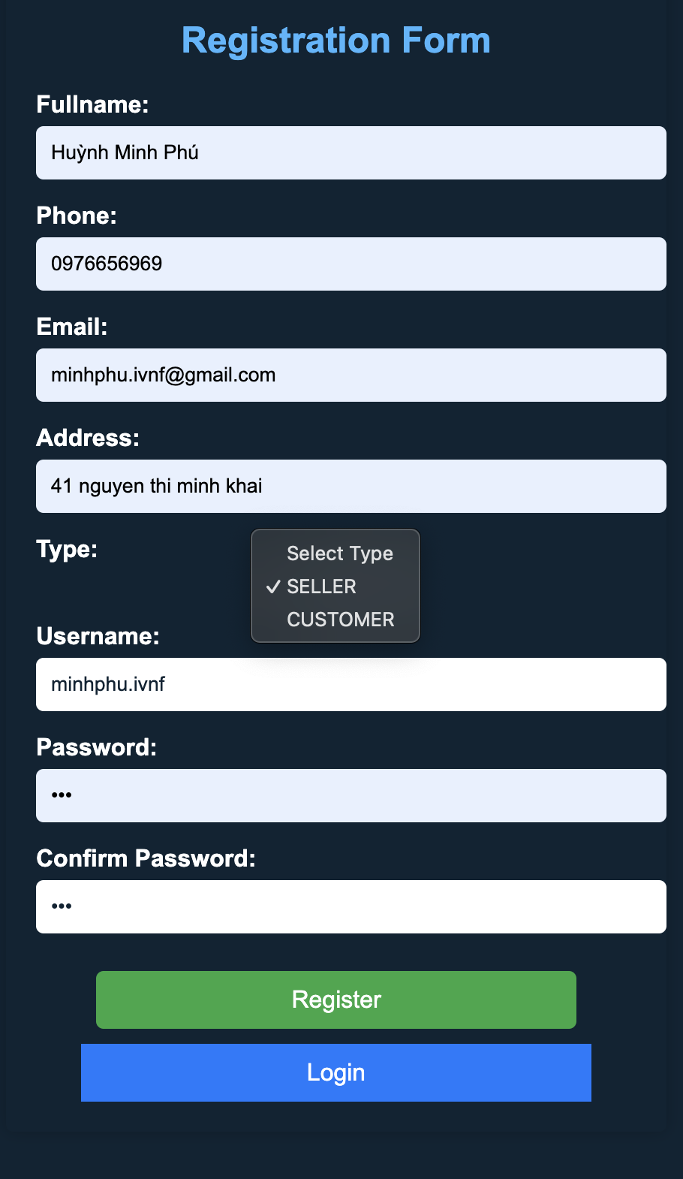

1. Save the submitted form value to database

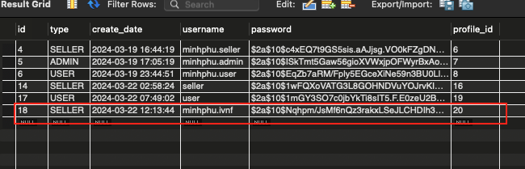

1. Display a Thank You page

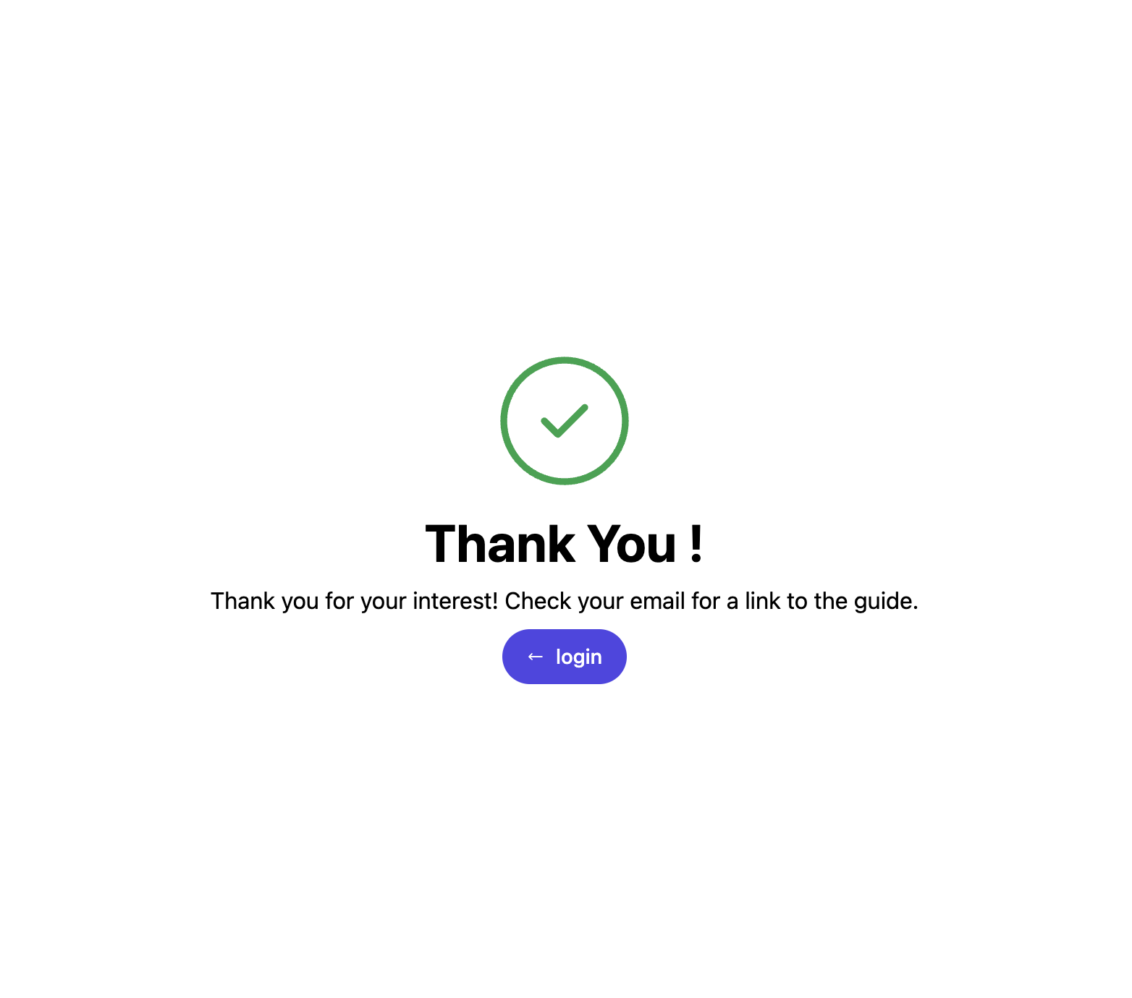

1. Provide the screen capture of database table structure, form, thank you page and the data stored in database table
   1. Database table structure

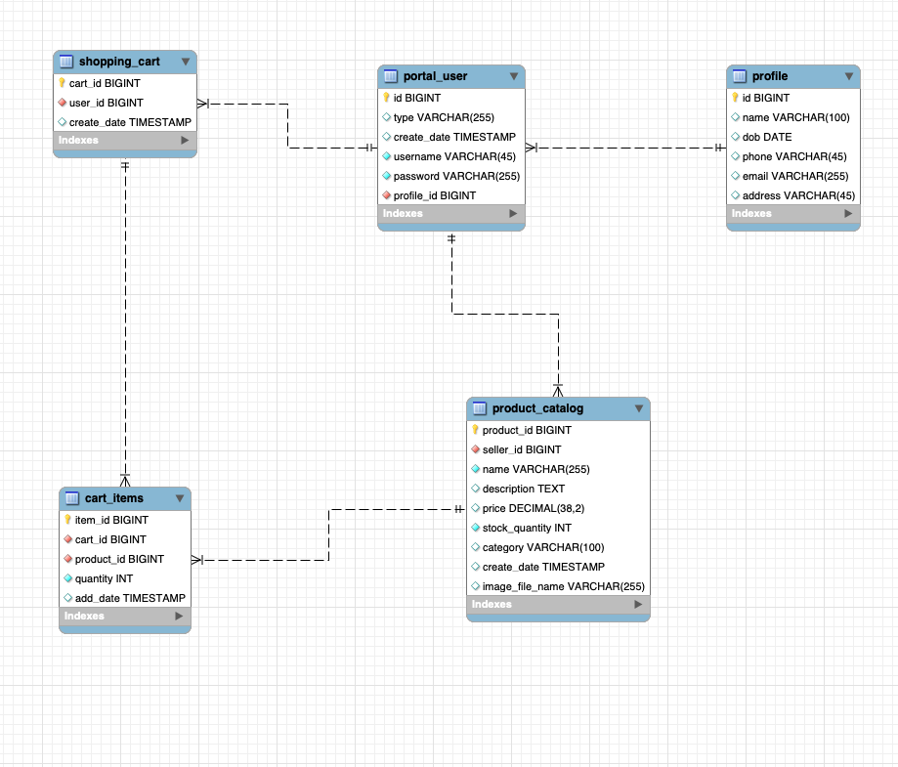

* 1. Form register

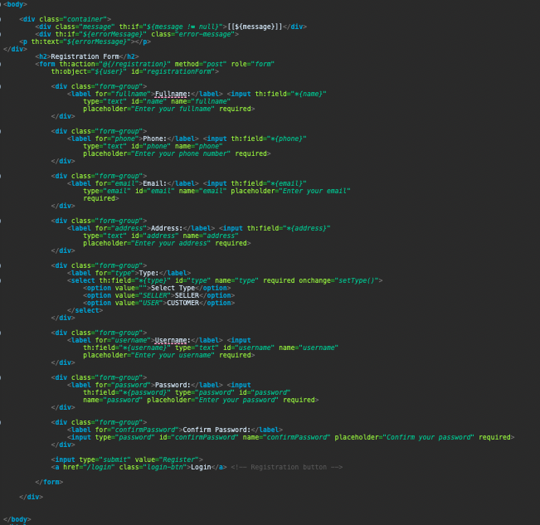

* 1. Thank you page

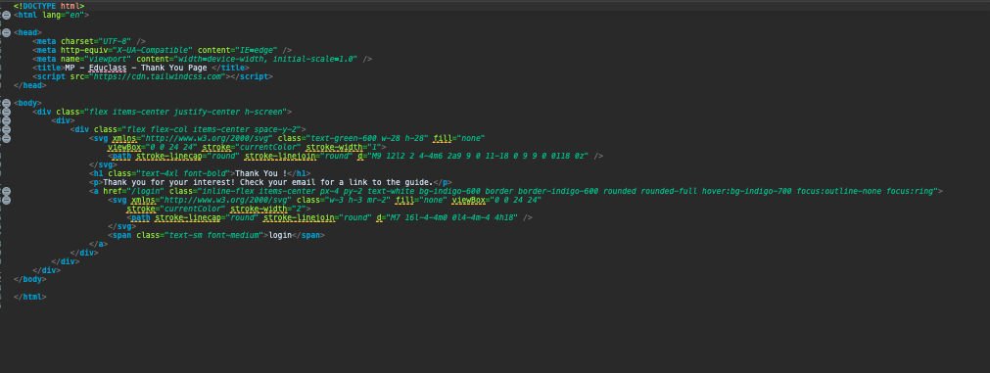

* 1. The data stored in database table

